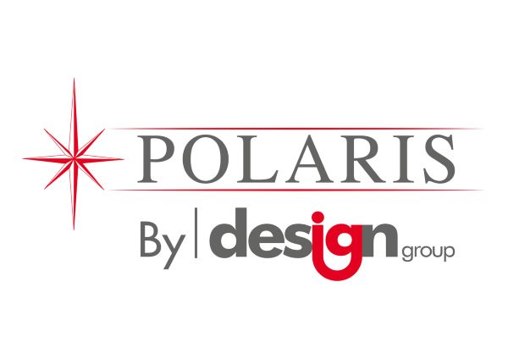
Product Specification Document
Issue: 1
Date 02/20 Product Code: INXJ
Product Name & Description: LDPE BLUE Sacks Page: 1 of 2

Description | Unit | Data | Tolerance
Closed Width | mm | 457 | +/- 2.5%
Open Width | mm | 737 | +/- 2.5%
Length | mm | 965 | +/- 2.5%
CHSA Min Nett Weight | kg | 4.73
Film Colour | na | BLUE
Opacity | % | 80
Blend Requirement | na | 100% Recycled LDPE
Print Requirement |  | NA | No Ink Lift
Handle Requirement | Yes/No  Style | No
Carton Qty |  | 200
Film Performance:
Description | Unit | Data | Tolerance
CHSA Ultimate Lift | Kg | 15Kg (Medium Duty ) | Manual Test
Seals |  | No Burst under air pressure | Manual Test
Visual inspection |  | Free from visual defects, and of consistent colour and finish. | Manual Test
Other |  | Sacks to be free from strong odour and demonstrate no blocking. | Manual Test

Product Name & Description: LDPE Black Sacks Page: 2 of 2
Carton Details:
Description | Unit | Data | Tolerance
Width | mm | 265 external | max
length | mm | 470 external | max
Height | mm | 100 external | max
Card type | Flue | Brown Outer Card, 150 kraft test, B flute, 3 ply | min
Label / Print |  | Printed 1 colour carton
Pallet Quantity | Count | 88 cartons (11 layers x 8)
Carton Strength |  | Carton must not crush under min of 12x weight.  Bulging Cartons not acceptable.

CARTON IMAGE:

Approved By | Date | Signature
Angela Kuzmic

